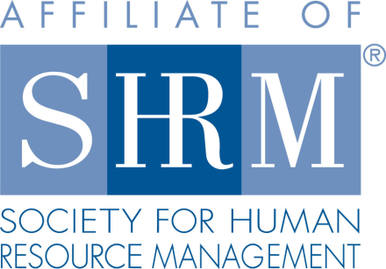
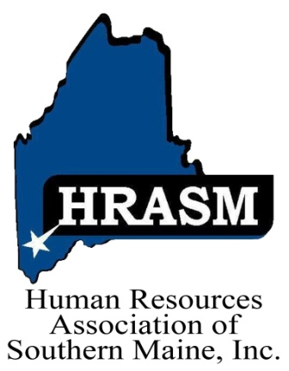

HRASM

Board of Directors Application Form

The Human Resources Association of Southern Maine (HRASM) is organized for the purpose to:

- Provide assistance for professional development of its members;
- Provide impetus for research in order to improve management skills;
- Serve as a focal point for the exchange of authoritative information;
- Make the general public aware of the Human Resources field in order to create a better understanding of its functions and importance;
- Allow Human Resources executives and their assistants to become involved in the previously four processes.

Board Qualifications:

- Must be willing to commit to at least one year term. (regular term is 3 years)
- Must attend a majority of the monthly meetings; bi-monthly board meetings and two strategy meetings per year
- Must be a HRASM and SHRM member and/or agree to submit for and maintain SHRM/HRASM membership throughout Board term

Biographical Information:

Name:

Title:

Company:

How long have you been a member of HRASM?

Do you belong to the national SHRM organization?

Designations: SPHR PHR SHRM-SCP SHRM-CP Not Currently Certified

Years of Experience in Human Resources:

Areas of Expertise:

What other associations do you belong to?

Board Interest:

- Why are you a member of HRASM?

- What can you contribute to the board and the association?

- What do you think is the association’s greatest strength and biggest weakness?

- What unique skills and talents do you feel you would bring to the board.

- Are there any particular areas of the association you are interested in, i.e. membership, professional development, treasurer, secretary, etc.?

Thank you for your interest in joining the Board of Directors for the Human Resources Association of Southern Maine. Applications will be reviewed and voted upon. Should you not be selected, we hope you keep the opportunity open for future board positions.

Date Submitted | Reviewed by Board (dated) | Notified

See attached General Statement of Duties

General Statement of Duties

Directors shall serve the membership and assist in the association’s purpose, which is to promote career development of the Human Resource professional. Board Members must be a both a SHRM and HRASM member in good standing.

Detailed Duties

- Serves as a member of the Board of Directors and attend a majority of Board and Association meetings.
- Participates in discussion, decision making, and implementation of the Association’s strategy, structure, by-laws, procedures and programs.
- Supports officer and committee roles and duties.
- Assist with coordination of Association events.
- Promotes professional development through attendance and participation at Association meetings and promotion of Human Resource Certification and other educational programs.
- Supports collaboration with other Human Resources associations.
- Mentors new board members.
- Networks with other Association members in an effort to communicate the
Association's mission, purpose and strategy.

Please forward responses to:

Shannon Kashinsky
Skashinsky@peopleschoiceme.org

